

**Neumann János Egyetem**

**GAMF Műszaki és Informatikai Kar**

GSZABAN-RAPIDWAD-1 –

Gyakorlatvezető: Dr. Subecz Zoltán

**Fehér Donát – ECFE35**

mérnökinformatika szak – levelező tagozat

Rapid web-application development with Laravel framework - online course

I have chosen the <https://taxdesignation.org/> nonprofit foundation’s webpage to recreate.

The following paths have been defined in web.php. / Dashboard is only available after login. The authentication is provided by Laravel Breeze, which I used for the project with the recommendation of an acquaintance. It also handles login and registration. It also receives get and post http requests on the /contact path.

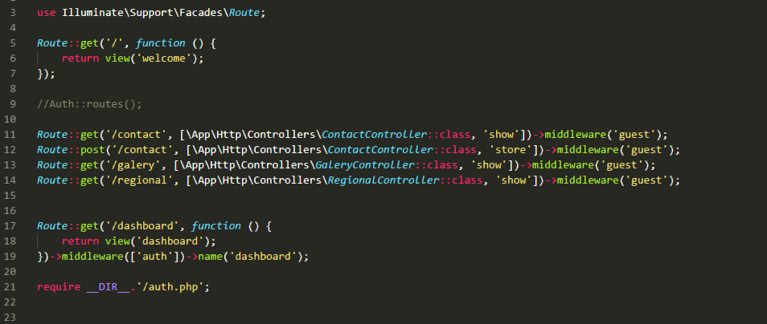

Login screen:

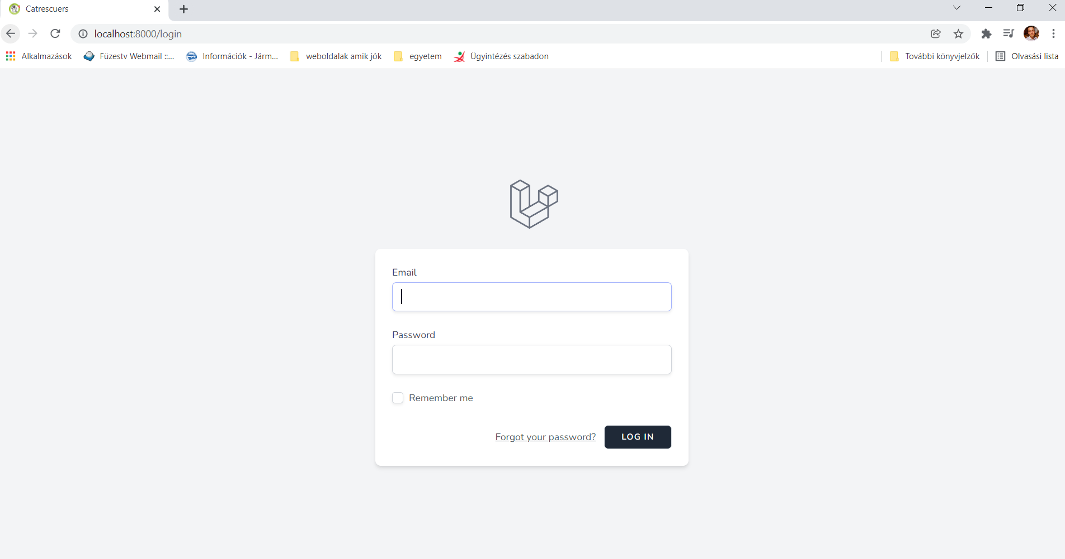

Register screen:

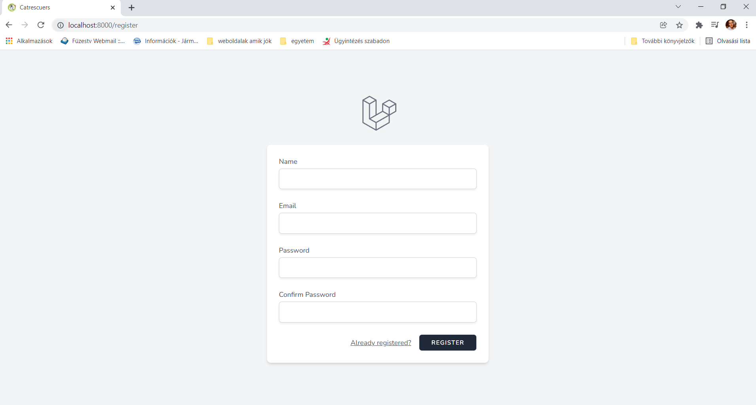

A multi-level menu has also been implemented, which also includes the address of the current website of the selected non-profit organization.



Contact menu:

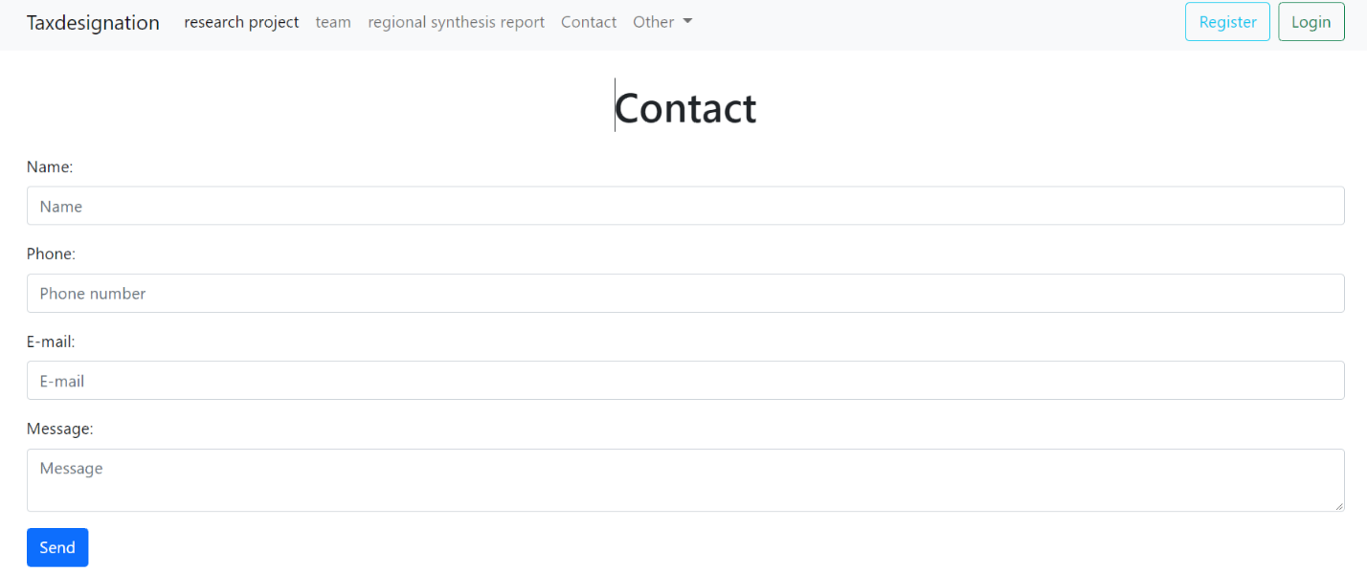

If the data processing was successful and the provided data meet the required criteria, we will be notified in the following form: 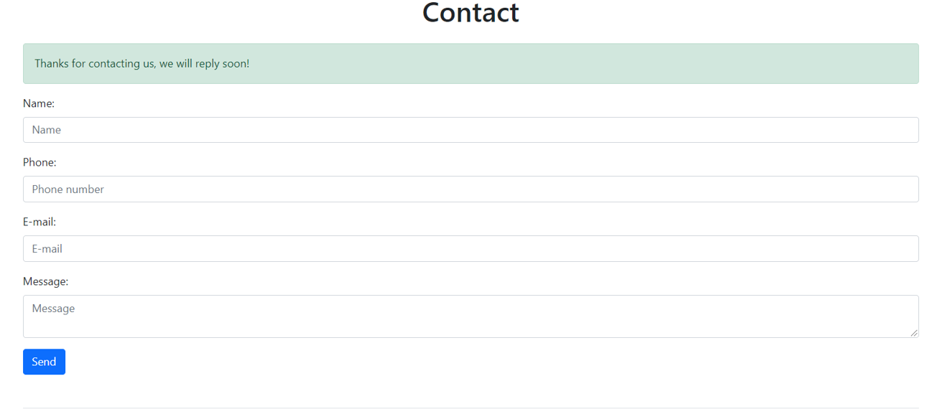

Validation was implemented on the server side in the ContactController. There were only so many requirements for the data that the name, phone number and email address field were mandatory.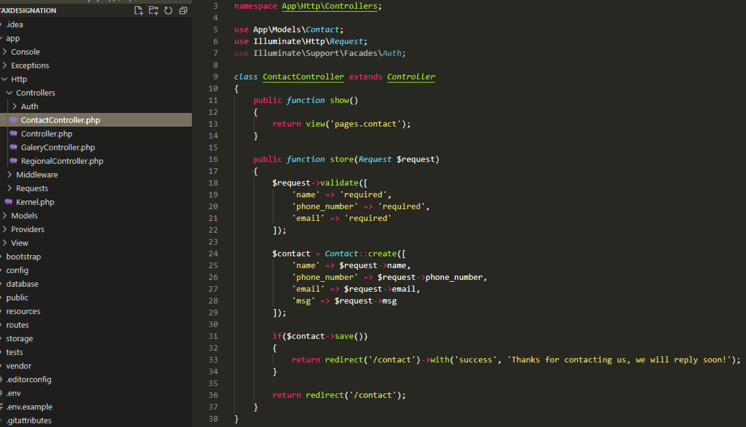

If the data does not meet the specified conditions, you will receive an error message.

The Contact and Gallery and User models have also been created. A separate migration was also created for each database table. Example of one migration (contact):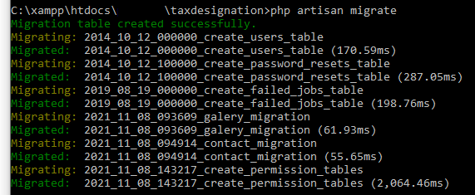 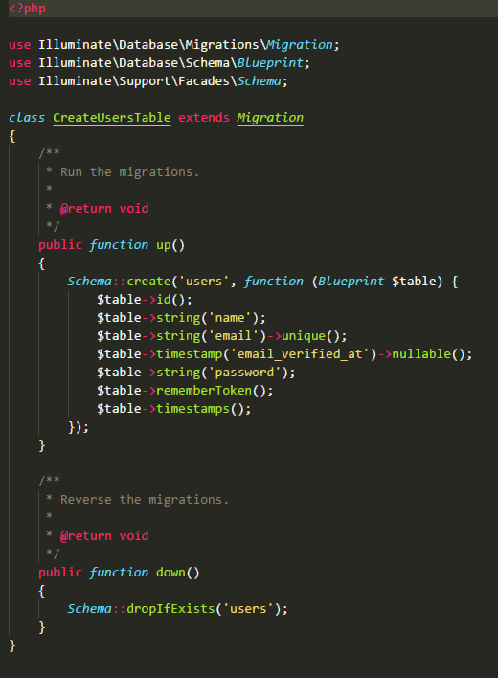

Seeders have been created for several tables, an example of one seeder (UserSeeder): 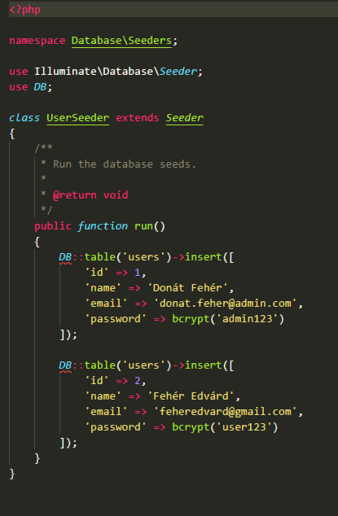

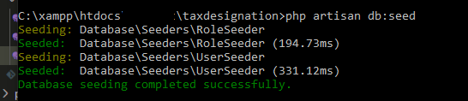

Due to the success of the migration and seeding, the tables are created and the data was loaded into it: 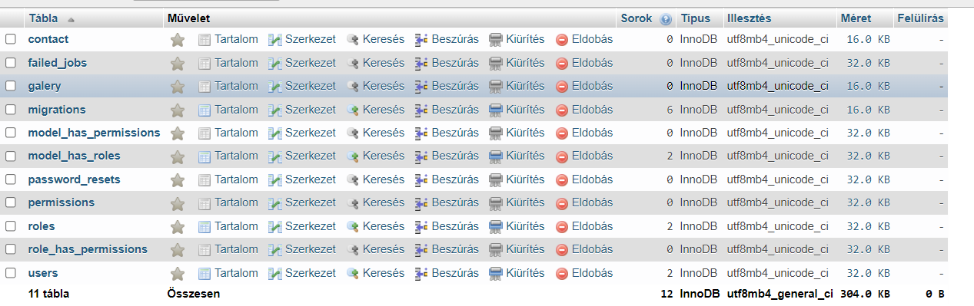

Seeded Data:

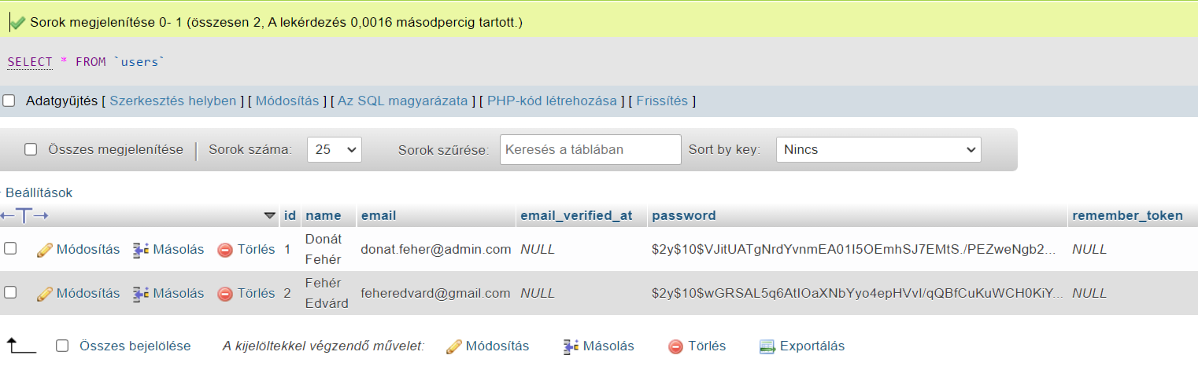

I used the latest bootstrap 5 currently available everywhere to implement the frontend. The website is fully responsive.

Phone:



PC:



Which, unfortunately, have not been implemented:

Roles, photo gallery and the saved messages (under contact menu) will not be displayed in the admin interface. Although these were prepared, but due to lack of time and knowledge, I was unable to complete these tasks.

Github link: [https://github.com/Dodni/Laravel-online-class-assignment](https://github.com/Dodni/Laravel-online-class-assignment%20)